**FUN FACTS**

“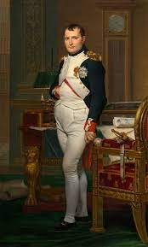Blackjack” originates from a ten-to-one payout if the player's hand consisted of the ace of spades and a black jack. The name stuck even after the ten-to-one bonus was withdrawn.

One of blackjack’s biggest fans was none other than Napoleon Bonaparte. He played the game regularly, especially after he was exiled in Elba.

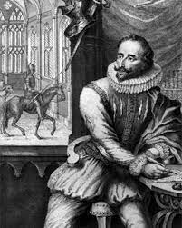

The first written mention of blackjack was in a collection of short stories by Miguel de Cervantes, the author of “Don Quixote.”